DSA with Java
-Created by Robin Mejo AM(23-10-2026)- 1192376
Day 1
Big O is the way of finding how efficient a code will run
Time complexity, it is not measured in time, it is measured in no of operations that it takes to do something
Space complexity


Omega, theta and omicron
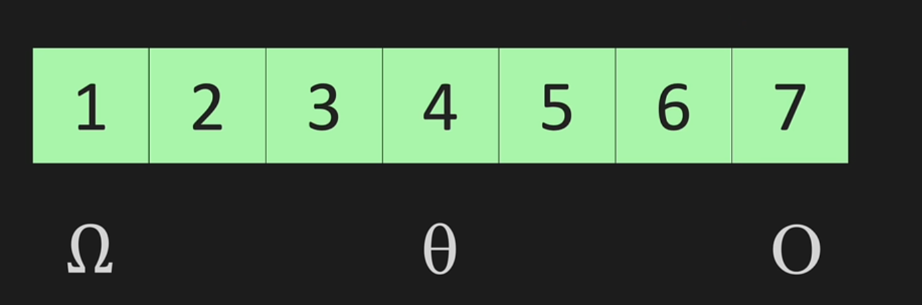

Here we are cutting 3 times till we get 1 from sorted array

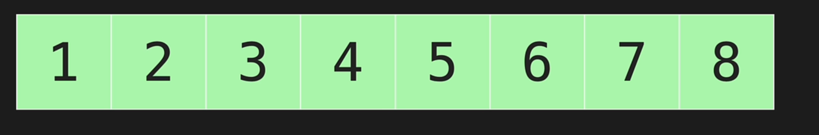

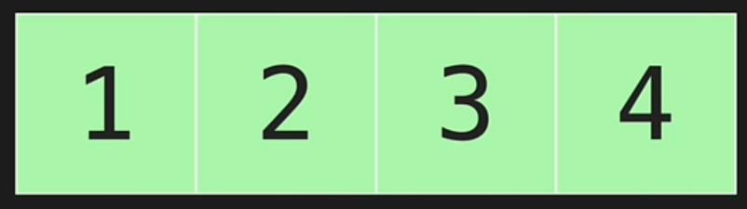

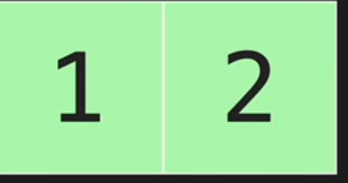

2³= 8
Log ₂8=3
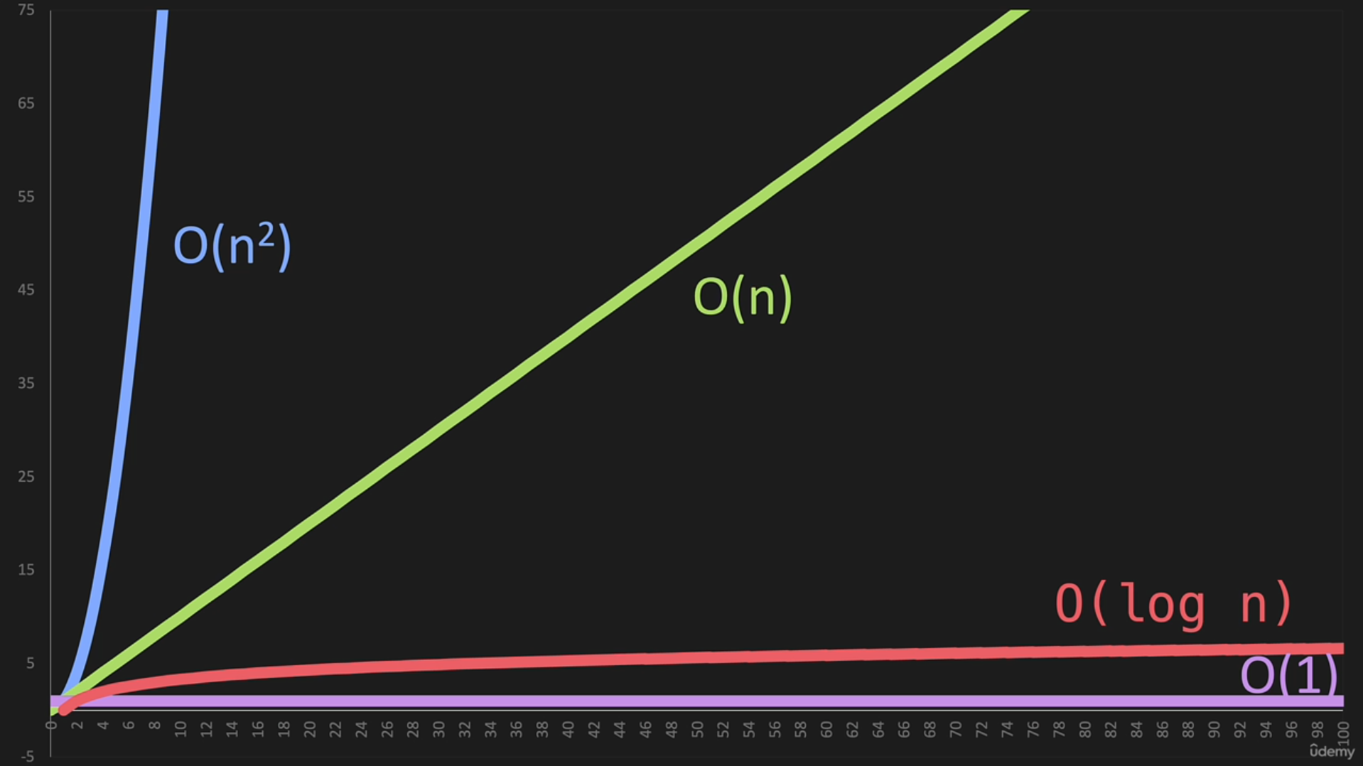
Below is used in some sorting alogorithms like merge sort and quick sort
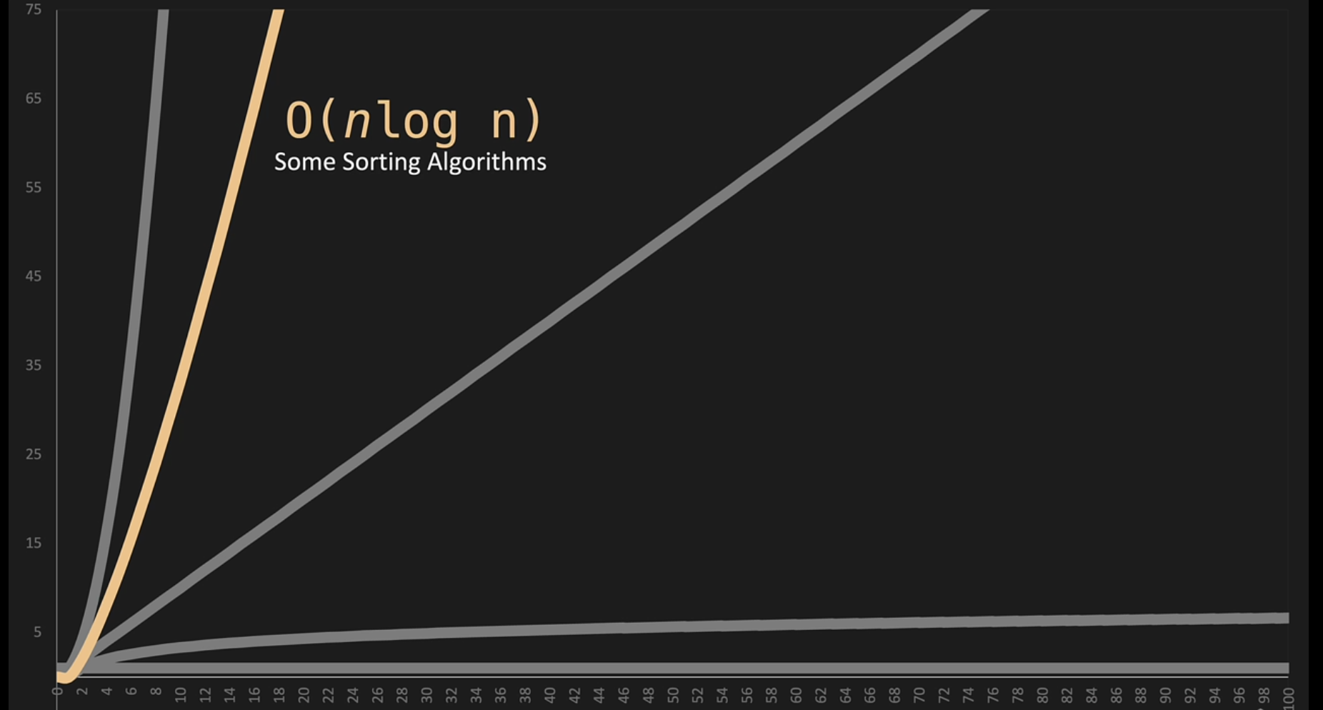

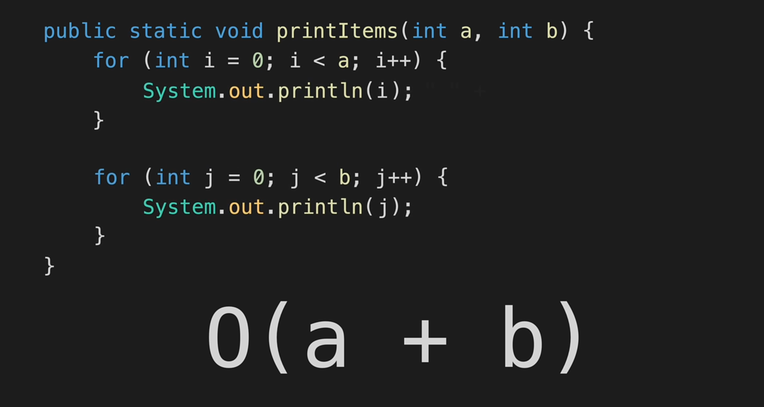
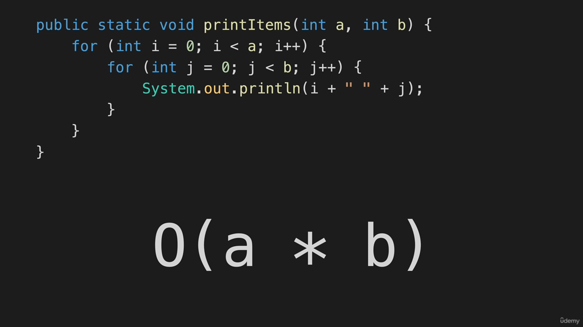
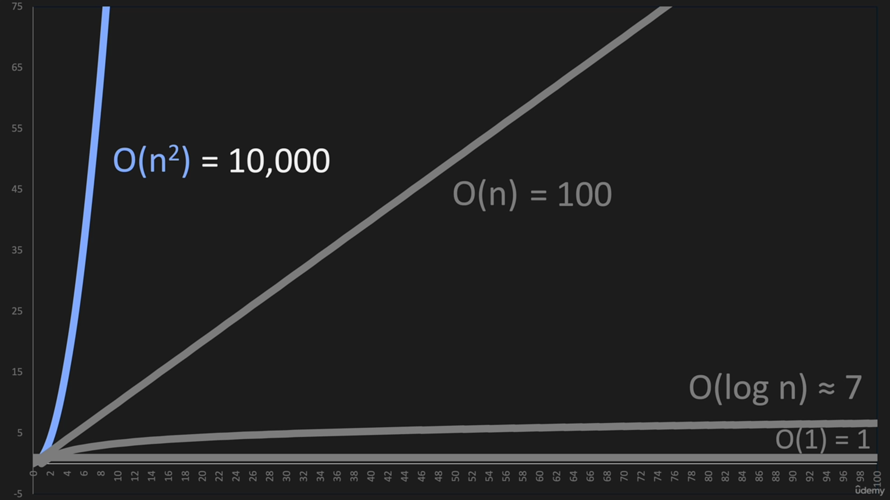

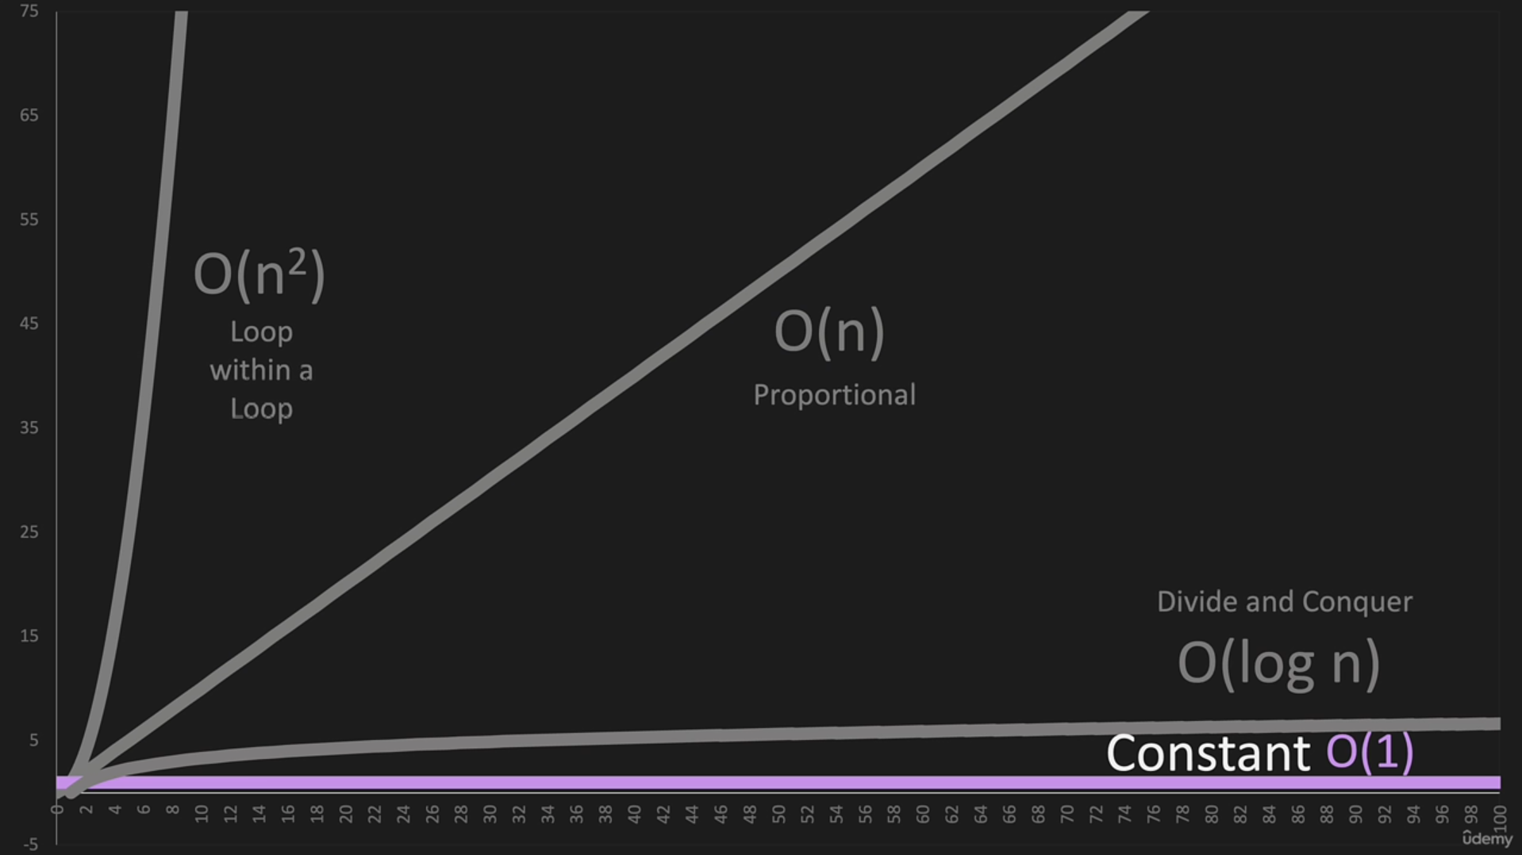

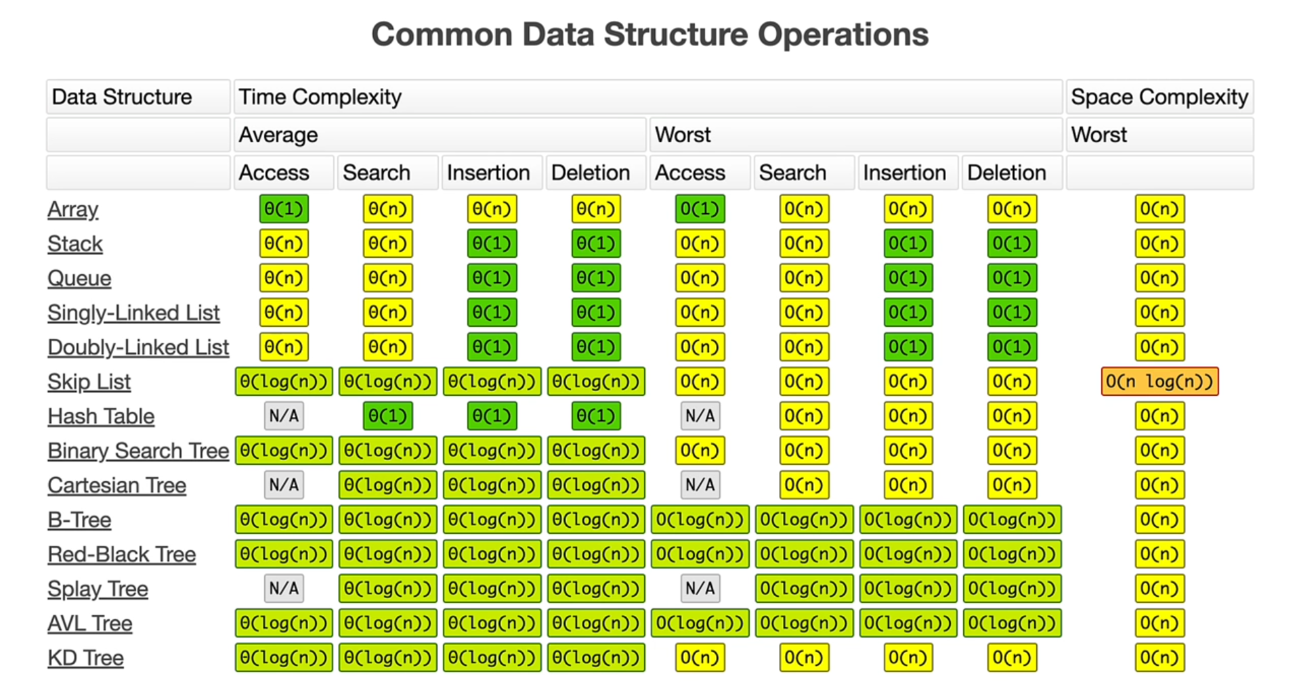

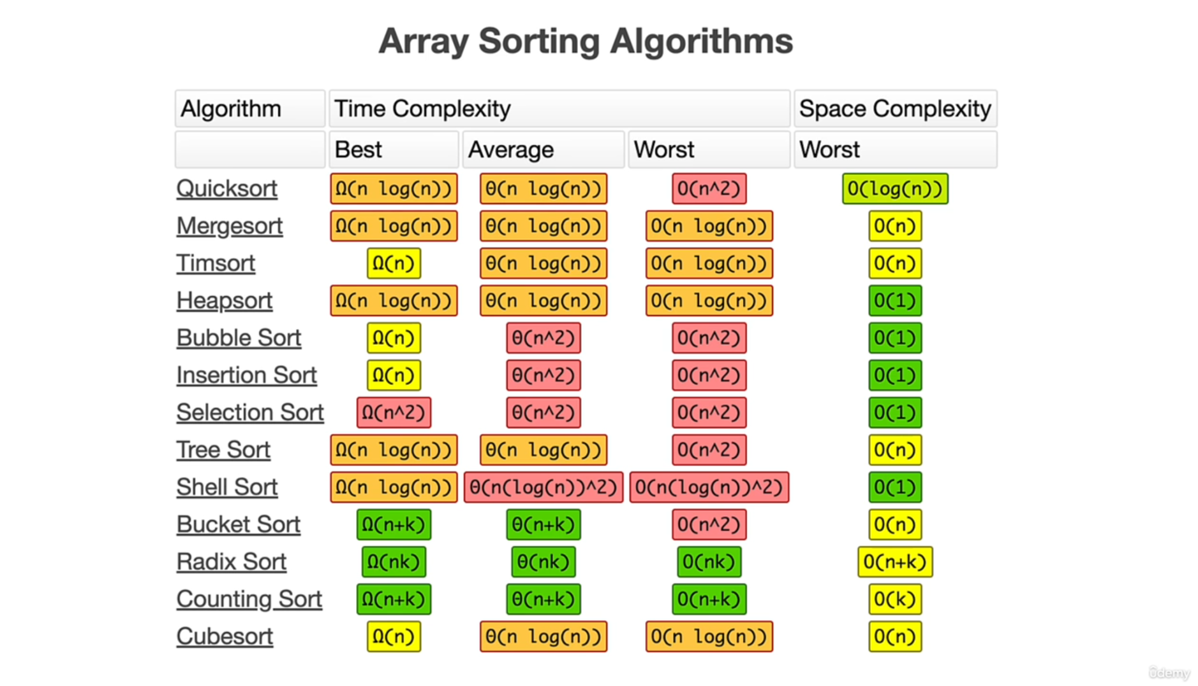

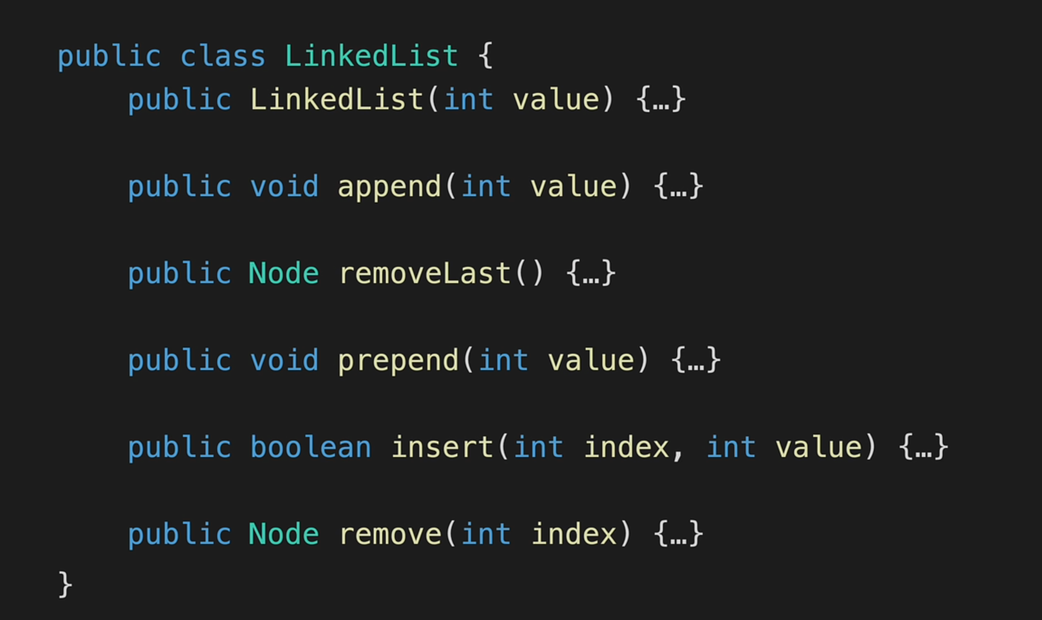
Interview tip: List is an interface, while ArrayList and LinkedList are concrete classes that implement it.
Remember this for interviews 🎯
- List, Set, and Queue extend Collection.
- Map does not extend Collection.
- ArrayList, LinkedList, and HashMap are classes.
- List, Set, Queue, and Map are interfaces.
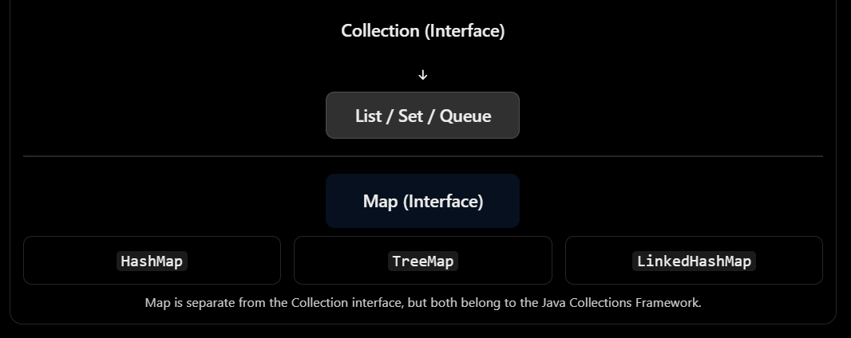
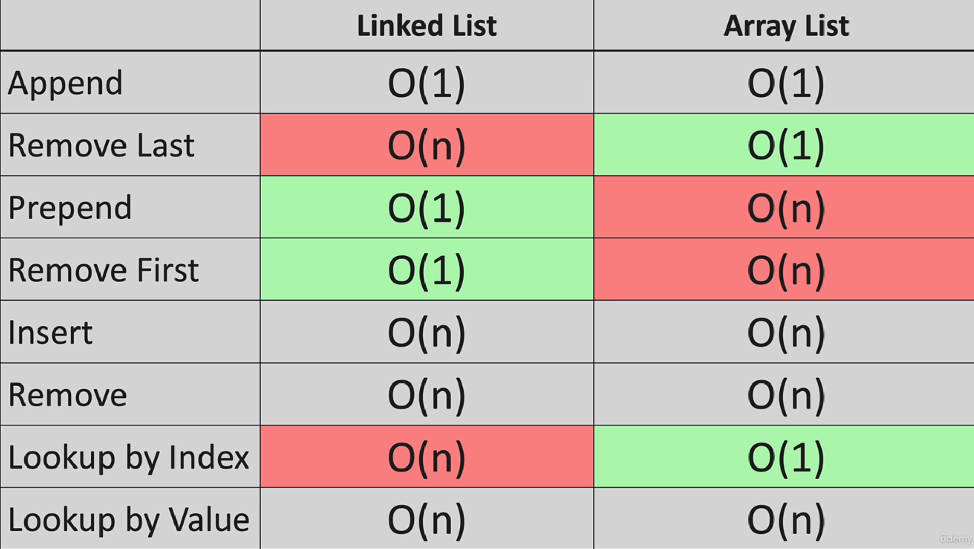

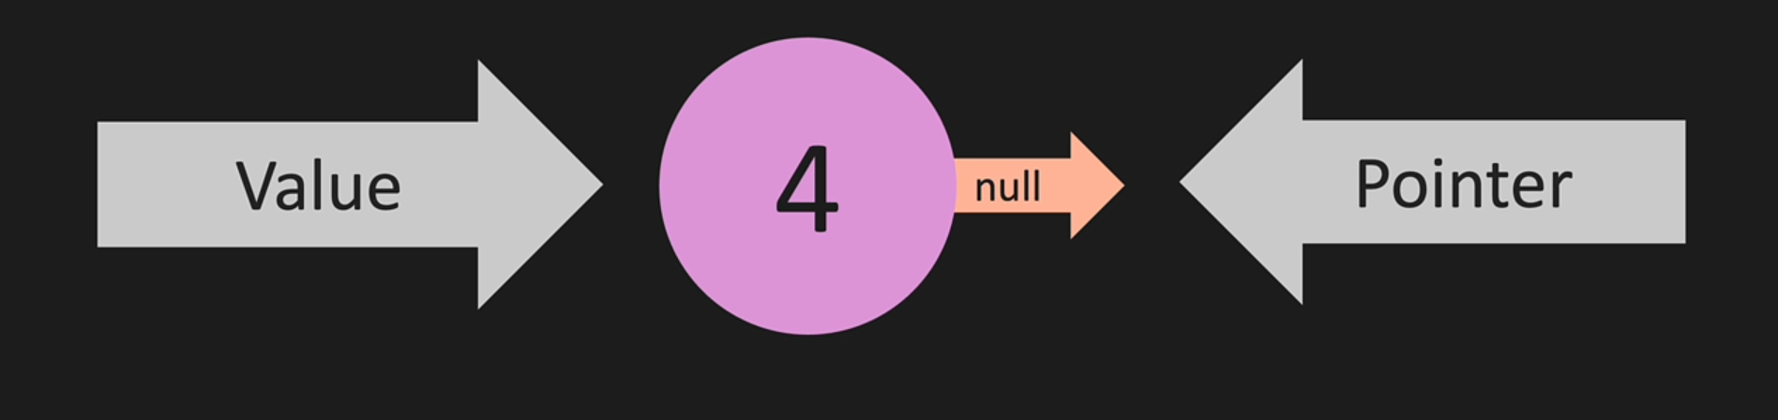

Node is something like this it has a value and a pointer , so we are using hashmap which is similar to this just for learning

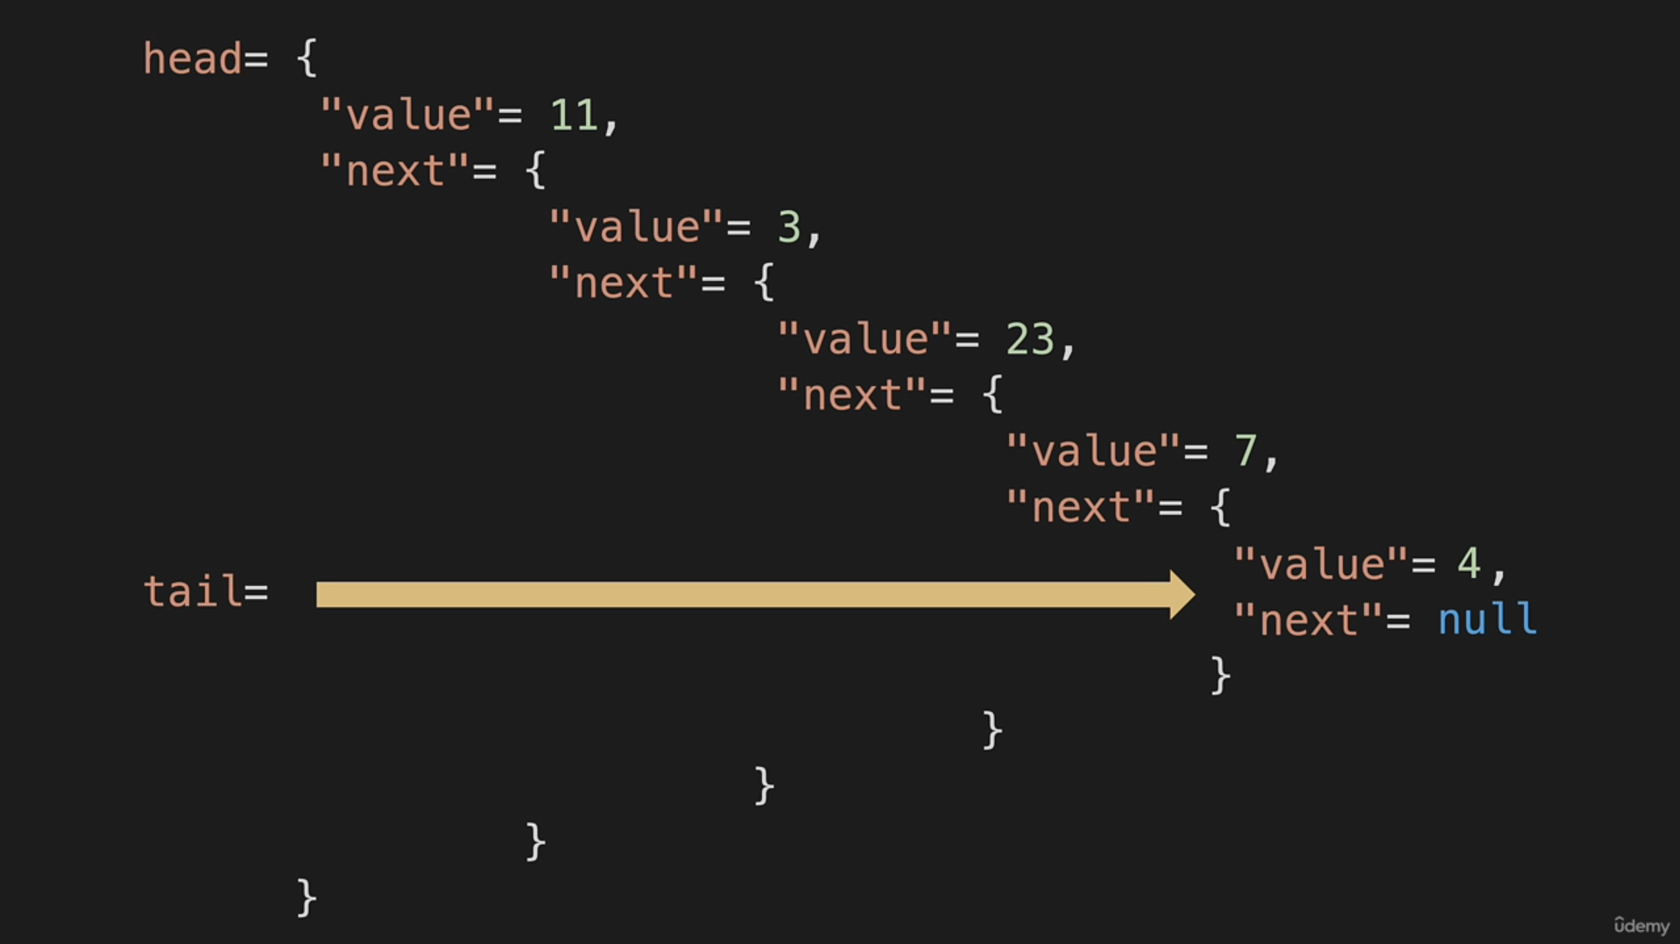
Java allows only one public top-level class per .java file, and the filename must match that class.

